Name: Quang Huynh Date: 1/12/22

**Your Urinalysis – The Composition of Your Urine**

**Introduction**  
The major function of the **urinary system** is to *remove waste products from our bodies* and help *regulate the volume and composition of blood* by the production and excretion of urine. The urinary system consists of two **kidneys**, two **ureters**, one **bladder**, and one **urethra**.

The composition of urine can vary greatly and constantly fluctuates with dietary intake (food and water) and metabolic activity. Urine consists mostly of **water** with various organic and inorganic substances such as **urea, uric acid, creatine, sodium chloride, ammonia, sulfates,** and **phosphates** as its principal ingredients. A clinical examination of urine can provide a convenient, cost effective and non-invasive means of assessing kidney function and providing an overall assessment of our body's health.

Typically, a complete urinalysis involves an examination of the physical characteristics of urine, a chemical analysis and a microscopic examination of urine sediment. In this activity you will be doing a chemical analysis of your own urine in the privacy of your own home.

**NOTE:** Please use caution in the handling of urine specimens. Only handle your own urine! Discard cups, urine, and dipsticks as indicated by the instructor.

READ ALL OF THE FOLLOWING REFERENCE MATERIALS AND INSTRUCTIONS BEFORE PERFORMING ANY PART OF THE URINALYSIS. You will then record your data in the chart that follows. You should also photograph your dipstick next to the dipstick chart so you can refer to it later.

**Materials**

At-Home Urinalysis Kit (Dipstick, Dipstick Chart, Cup, 1 Alcohol Wipe)

**Pre-Lab Questions**

1. **Urine formation is the result of what 3 processes?**

Glomerular filtration Tubular reabsorption Tubular secretion

2. **What are the most common components of urine (list 3)?**

Urine is mostly composed of urea, water and amino acids.

3. The bladder is composed of **transitional** epithelial cells which allow for tissue to expand.

**Procedure**

For routine chemical analysis of urine there are several brands of chemical test strips (dip sticks) that are commercially available. These urinalysis test strips have small test patches impregnated with various chemicals in order to detect the presence or absence of certain substances. Qualitative and/or quantitative results can be obtained depending on the particular test.

1. Take a specimen cup from your kit to your bathroom; follow the “clean catch” procedure discussed in class; urinate into the cup.
2. 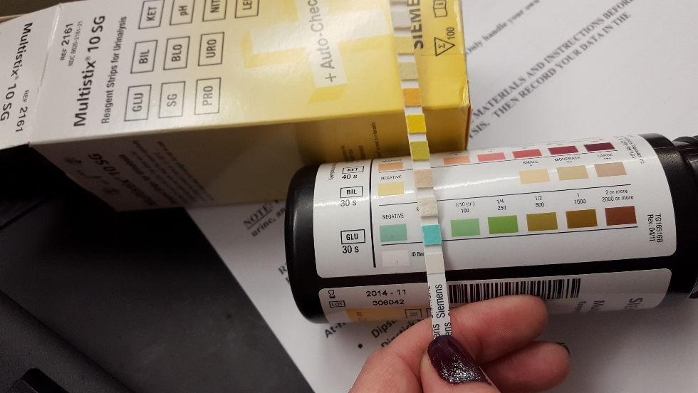Briefly (one second or less) dip the test strip into the urine.  Make sure that all test  
   squares are immersed.
3. Draw the edge of the strip along the rim of the specimen cup to remove excess urine.
4. Hold the strip on the printing that reads “Siemens.” After 30 seconds, compare the second square that is closest to your thumb to the color chart for GLU (glucose).
5. Read from this square up, being mindful of the time values.

***NOTE:  For convenience, **all values on the strip may be read between 1 and 2 minutes after immersion**.  The colors are stable for up to 120 seconds after immersion.  Color changes that occur after 2 minutes from immersion are not of diagnostic value.  Color changes that occur only along the edge of the test area should be ignored.

1. Results are obtained by direct visual comparison with the color scale printed on the vial label. No calculations are necessary.  Record your results on the following table.
2. **NOTE:**  For such a test to be considered clinically acceptable for a valid diagnosis, careful quality control should be maintained, i. e. expiration dates respected, environmental conditions stabilized, etc.  In a teaching lab these conditions are not met.  You can learn the procedure and see some variable results among the class members, but do not base any clinical assumptions on the results obtained in this lab.  If you have any reason to suspect a clinical problem, go to a licensed medical laboratory for a urinalysis.

**Data Chart:**

|  |  |  |
| --- | --- | --- |
| **Test** | **Results for**  **Student Specimen** | **Normal Results** |
| Color and Odor |  | ***Light yellow to amber-colored*** |
| Turbidity |  | ***Transparent or clear*** |
| Leukocytes (LEU) |  | ***Negative*** |
| Nitrite (NIT) |  | ***Negative*** |
| Urobilinogen (URO) |  | ***0.2 - 1.0*** |
| Protein (PRO) |  | ***Negative or Trace*** |
| pH |  | ***6.0*** |
| Blood (BLO) |  | ***Negative*** |
| Specific Gravity (SG) |  | ***1.005 - 1.035*** |
| Ketones (KET) |  | ***Negative*** |
| Bilirubin (BIL) |  | ***Negative*** |
| Glucose (GLU) |  | ***Negative*** |

**PHYSICAL CHARACTERISTICS OF URINE**

The physical characteristics of urine include observations and measurements of color, turbidity, odor, specific gravity, pH and volume. Visual observation of a urine sample can give important clues as to evidence of pathology.

**COLOR**

The color of normal urine is usually light yellow to amber. Generally the greater the solute volume the deeper the color. The yellow color of urine is due to the presence of a yellow pigment, **urochrome**. Deviations from normal color can be caused by certain drugs and various vegetables such as carrots, beets, and rhubarb. Is your urine clear, light yellow, dark yellow, or amber colored?

**ODOR**

Slightly aromatic, characteristic of freshly voided urine. Urine becomes more ammonia-like upon standing due to bacterial activity. Is the smell of your urine not-noticeable, slight (normal) urine smell, or very aromatic?

**TURBIDITY**

Normal urine is transparent or clear; becomes cloudy upon standing. Cloudy urine may be evidence of phosphates, urates, mucus, bacteria, epithelial cells, or leukocytes. Is your urine clear or cloudy?

**pH**

Ranges from 4.5 - 8.0. Average is 6.0, slightly acidic. High protein diets increase acidity. Vegetarian diets increase alkalinity. Bacterial infections also increase alkalinity.

**SPECIFIC GRAVITY**

The specific gravity of urine is a measurement of the density of urine - the relative proportions of dissolved solids in relationship to the total volume of the specimen. It reflects how concentrated or dilute a sample may be. Water has a specific gravity of 1.000. Urine will always have a value greater than 1.000 depending upon the amount of dissolved substances (salts, minerals, etc.) that may be present. Very dilute urine has a low specific gravity value and very concentrated urine has a high value. Specific gravity measures the ability of the kidneys to concentrate or dilute urine depending on fluctuating conditions. Normal range 1.005 - 1.035, average range 1.010 - 1.025.

**Low specific gravity** is associated with conditions like diabetes insipidus, excessive water intake, diuretic use or chronic renal failure.

**High specific gravity** levels are associated with diabetes mellitus, adrenal abnormalities or excessive water loss due to vomiting, diarrhea or kidney inflammation. A specific gravity that never varies is indicative of severe renal failure.

|  |  |
| --- | --- |
| **ABNORMAL CONSTITUENT** | **ASSOCIATED CAUSES** |
| **Protein (albumin)** | Albumin is normally too large to pass through glomerulus. Indicates abnormal increased permeability of the glomerulus membrane. *Non-pathological causes are: pregnancy, physical exertion, increased protein consumption. Pathological causes are: glomerulonephritis bacterial toxins, chemical poisons.* |
| **Glucose** | Glycosuria is the condition of glucose in urine. Normally the filtered glucose is reabsorbed by the renal tubules and returned to the blood by carrier molecules. If blood glucose levels exceed renal threshold levels, the untransported glucose will spill over into the urine. *Main cause: diabetes mellitus* |
| **Ketones** | Ketone bodies such as acetoacetic acid, beta-hydroxybutyric acid, and acetone can appear in urine in small amounts. These intermediate by-products are associated with the breakdown of fat. *Causes: diabetes mellitus, starvation, diarrhea* |
| **Bilirubin** | Bilirubin comes from the breakdown of hemoglobin in red blood cells. The globin portion of hemoglobin is split off and the heme groups of hemoglobin is converted into the pigment bilirubin. Bilirubin is secreted in blood and carried to the liver where it is conjugated with glucuronic acid. Some is secreted in blood and some is excreted in the bile as bile pigments into the small intestines. *Causes: liver disorders, cirrhosis, hepatitis, obstruction of bile duct* |
| **Urobilinogen** | Bile pigment derived from breakdown of hemoglobin. The majority of this substance is excreted in the stool, but small amounts are reabsorbed into the blood from the intestines and then excreted into the urine. *Causes: hemolytic anemias, liver diseases* |
| **Hemoglobin** | Hemoglobinuria is the presence of hemoglobin in the urine. *Causes: hemolytic anemia, blood transfusion reactions, massive buns (blood urea nitrogen) , renal disease* |
| **Red blood cells** | Hematuria is the presence of intact erythrocytes. Almost always pathological. *Causes: kidney stones, tumors, glomerulonephritis, physical trauma* |
| **White blood cells** | The presence of leukocytes in urine is referred to as pyuria (pus in the urine). Causes: urinary tract infection |
| **Nitrite** | Presence of bacteria. *Causes: urinary tract infection* |

**Analysis Questions:**

1. **Did you notice anything unusual about your urine? If so, please mention which test(s) deviated from the normal.** In my test,
2. **Why do you think that the first time a healthy person urinates after sleeping for an extended period of time that they would have a high ketone level?**

A healthy person urinates after sleeping after a long time would indicate that they have a high ketone level because while a person is sleeping, they are not getting any glucose in their system. Essentially, they are fasting while they sleep.

1. **A healthy football player found intact erythrocytes in their urine. What is the most probable cause?**

If there are intact erythrocytes in urine, then the most probable cause is hematuria.

1. **Which tests would be elevated in someone with diabetes?**

Someone with diabetes would have an elevated test in glucose since there is too much sugar in the blood.

1. **Which tests would be positive in someone with cystitis (urinary tract infection)?**

If someone that was positive with cystitis performed a test, then they would have a positive nitrite test.

1. **What would you expect in a urine sample of a person who is dehydrated?**

In a urine sample of someone who is dehydrated, the urine has a darker shade of yellow. This is due to the urine containing more urea and caused by not enough fluids in the kidneys being filtered out.